1. **Initial Screen to Login**

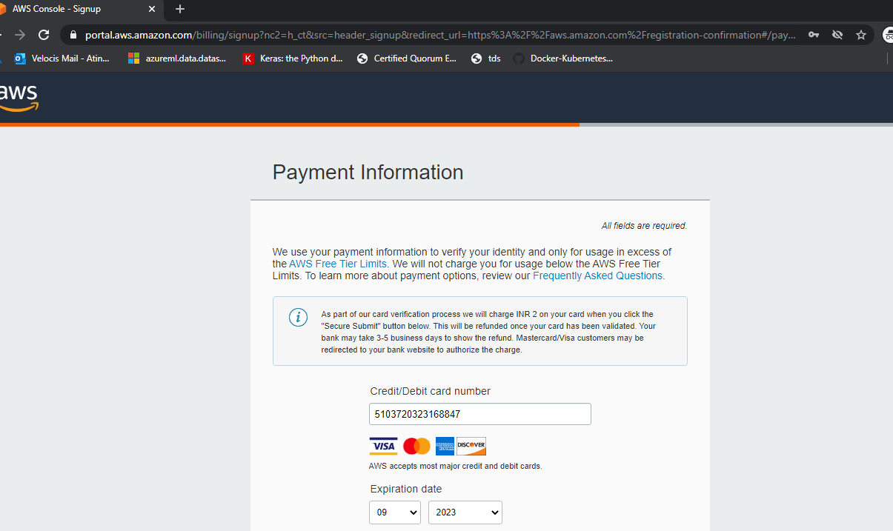

1. **Debit Card Details submitted**

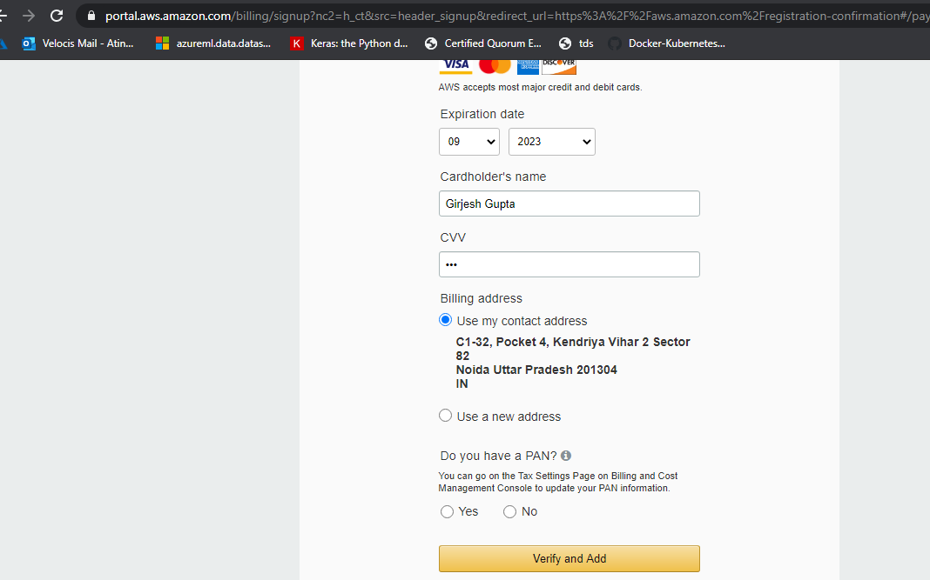

1. **After Click on Verify and Add, it’s not moving further and it freezes as below:**

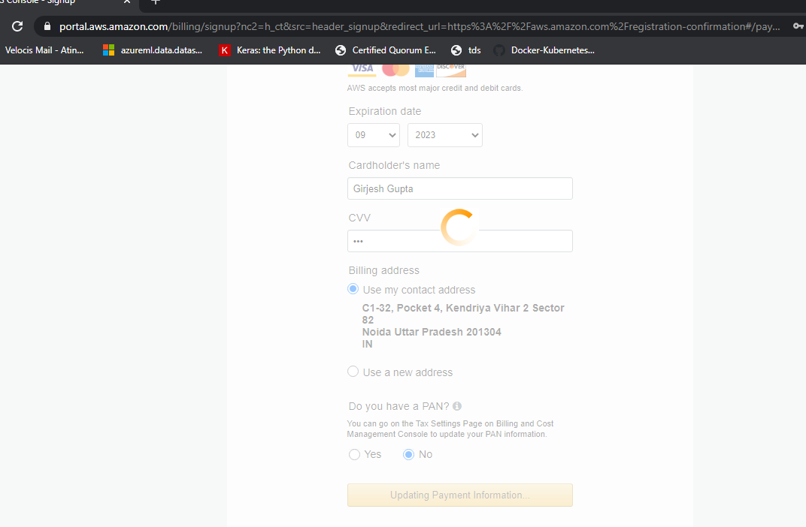

What we have tried:

1. Used different Debit cards and Credit Cards
2. Used different browsers
3. Used Incognito mode
4. Internet speed is 100 MBPS
5. Card details are 100% correct

The same issue is with most of the participants. Approximately 18 participants are facing this issue and unable to register.